

Guideline for the Installation and Documentation of Survey Control Marks

Special Publication 1

(ICSM)

Permanent Committee on Geodesy (PCG)

24 September 2014

Document History

|  |  |  |  |  |
| --- | --- | --- | --- | --- |
| DATE | VERS | ISSUE | AMENDMENTS | AUTHOR(S) |
| 24/10/2013 | 2 | 0 | Document available | ICSM Permanent Committee on Geodesy |
| 24/09/2014 | 2 | 1 | Figure 3 edited, copyright updated | ICSM Permanent Committee on Geodesy |
|  |  |  |  |  |



© Commonwealth of Australia (ICSM) 2014

With the exception of the ICSM logo and where otherwise noted, all material in this publication is provided under a Creative Commons Attribution 3.0 Australia Licence (<http://www.creativecommons.org/licenses/by/3.0/au/>)

Table of contents

Document History ii

Table of contents iii

List of figures iii

Terms and definitions iv

1 About this Guideline 1

1.1 Introduction 1

1.2 Normative References 1

2 Connection to datum 2

3 Characteristics of a survey control mark 2

4 Survey control mark information 6

List of figures

Figure 1: Survey control mark brass plaque design details 3

Figure 2: Survey control mark brass plaque placement details in existing kerb or rock 4

Figure 3: Deep seated permanent survey control mark 5

Terms and definitions

For the purpose of this Guideline, the terms and definitions listed below and those listed in the *Standard for the Australian Survey Control Network – Special Publication 1, Version 2.1* apply.

|  |  |
| --- | --- |
| Term/Acronym | Definition |
| Multipath | Errors in GNSS observations caused by reflected GNSS signals interfering with the direct GNSS signal due to their common time origin but different path lengths. |
| RFI | Radio Frequency Interference – interference of GNSS signals in the presence of other radio frequency signals, causing an adverse effect on the GNSS signals recorded at a site. Common sources of RFI can include radio and television towers, microwave data links, power lines or transformers, and mobile phone towers. |

# About this Guideline

## Introduction

The availability of an accurate and reliable survey control mark network is critical to the integrity of the National Geospatial Reference System (NGRS). The purpose of this Guideline is to promote the adoption of uniform survey control mark installation and documentation practices to achieve the highest level of stability and integrity of Australia’s survey control mark network.

Australia’s network of survey control marks is the means by which the NGRS datums are realised, and is a fundamental component of the spatial data infrastructure in Australia. The stability of survey control marks is essential for ensuring the accuracy and reliability of quoted positions. A survey control mark may be either a conventional (or passive) ground survey monument, or an active survey monument such as a continuously operating reference station (CORS). This Guideline refers only to conventional survey control marks - for information specific to CORS infrastructure please refer to the *Guideline for Continuously Operating Reference Stations*.

This Guideline outlines ICSM's recommended practices for the selection, placement and documentation of survey control marks.

## Normative References

This Guideline should be read in conjunction with the *Standard for the Australian Survey Control Network – Special Publication 1, Version 2.1* herein referred to as the Standard.

The following documents may have relevance to the application of this Guideline.

**International Guidelines**

JCGM 100:2008, *Evaluation of Measurement Data – Guide to the Expression of Uncertainty in Measurement*, Joint Committee for Guides in Metrology – Bureau International des Poids et Mesures, Paris, France.

**SP1 Standard**

ICSM (2014), *Standard for the Australian Survey Control Network – Special Publication 1*, Version 2.1, Intergovernmental Committee on Surveying and Mapping, Canberra, Australia.

**SP1 Guidelines**

ICSM (2014), *Guideline for Continuously Operating Reference Stations*, Version 2.1, Intergovernmental Committee on Surveying and Mapping, Canberra, Australia.

**ICSM Technical Manuals**

ICSM (2006), *Geocentric Datum of Australia Technical Manual,* Intergovernmental Committee on Surveying and Mapping, Canberra, Australia.

ICSM (2007), *Australian Tides Manual – Special Publication 9,* Intergovernmental Committee on Surveying and Mapping, Wollongong, Australia.

# Connection to datum

Survey control marks established for Australia’s NGRS should be coordinated relative to the datums set out in Section 2 of the Standard.

# Characteristics of a survey control mark

A survey control mark should be:

* Made of good quality, durable, corrosion resistant materials. It should employ robust construction techniques and be installed in stable ground or in solid rock (Figure 1 and Figure 2), such that it is least likely to be subject to local displacement or other seasonal or periodic movements. If a survey control mark is to be installed in an unstable area, permanent marking may require placing deep-seated survey control marks (Figure 3) that penetrate the surface soil to the depth of refusal, thus bypassing the zone of seasonal or periodic influence.
* Installed in a location where it is least likely to be disturbed, damaged or removed, or to constitute a hazard, such that its long-term stability and usability is maximised.
* Permanently and clearly marked with a unique identifier to ensure unambiguous identification. A station identifier should be engraved or stamped on the survey control mark, or a durable tag with the identifier firmly attached. A marker post or indicator should be installed if a survey control mark will not be easy to find.
* Accessible to allow for its proper use; and
* Located in a position that maximises the use of various measurement techniques and connection to existing and future marks. For instance, a survey control mark that is intended to be observed using GNSS techniques will require an optimal sky view free of obstruction, multipath and radio frequency interference (RFI) sources.

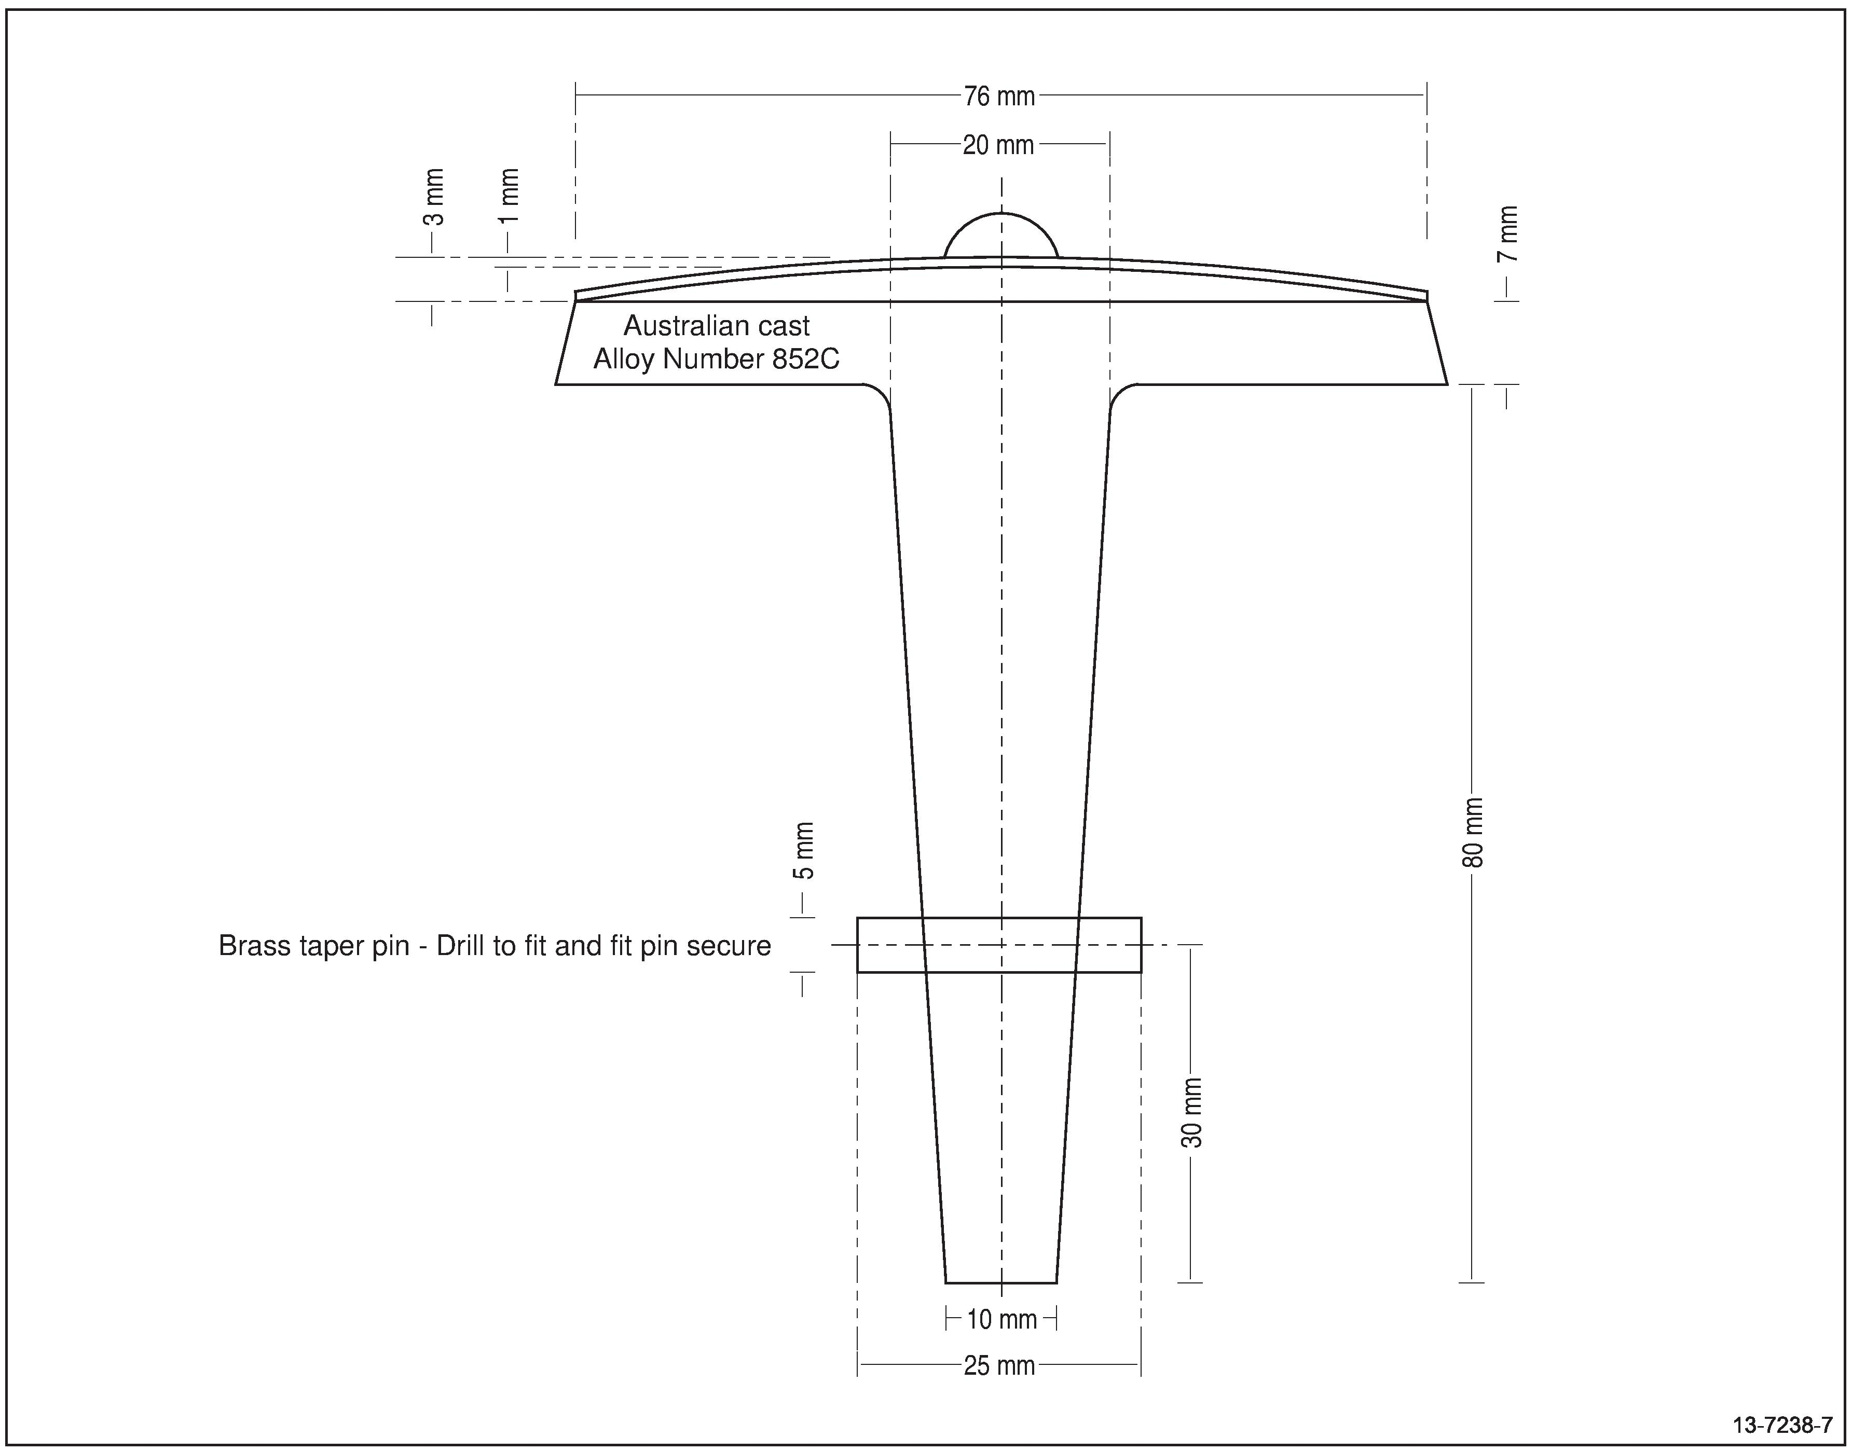

Figure : Survey control mark brass plaque design details

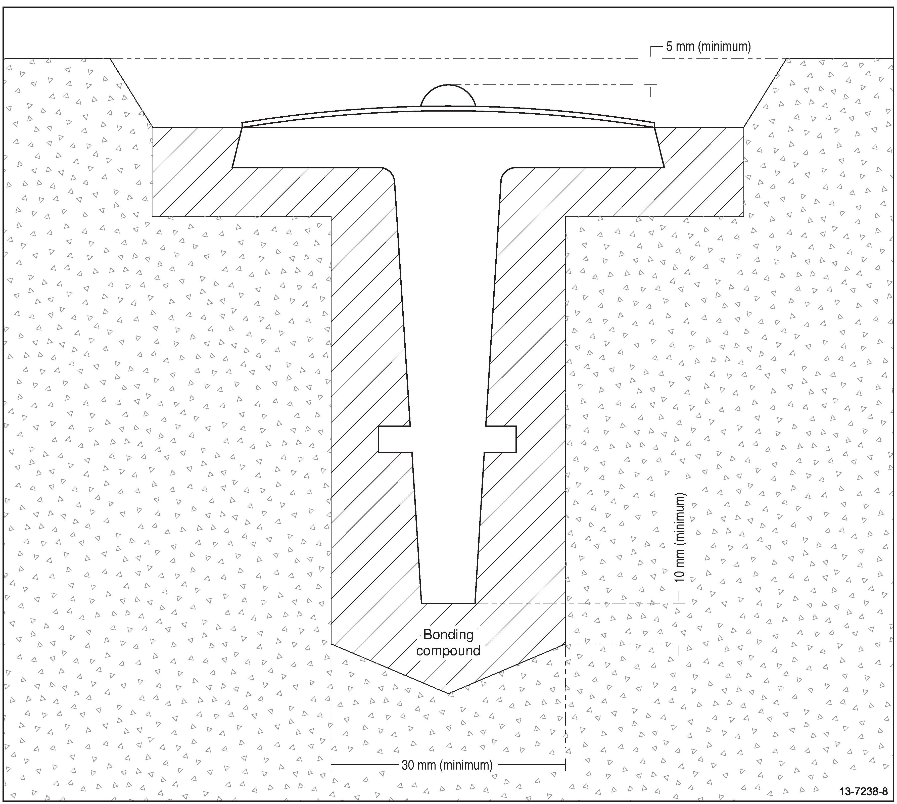

Figure : Survey control mark brass plaque placement details in existing kerb or rock

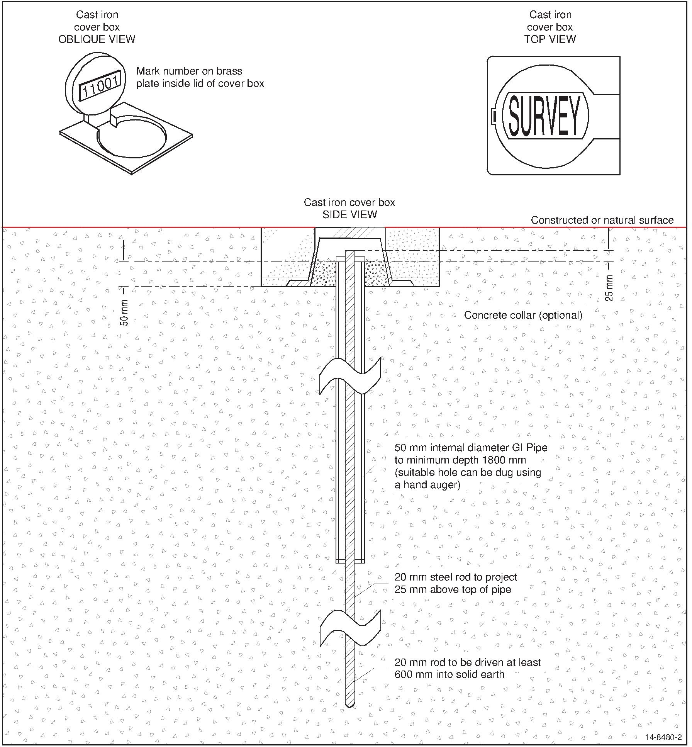

Figure : Deep seated permanent survey control mark

# Survey control mark information

When establishing new survey control marks for either Datum Control Surveys or General Purpose Control Surveys, the following information should be recorded:

* name, number and/or identifier used to uniquely identify the mark;
* date of installation;
* type and construction;
* location, access details, photograph and sketch plans; and
* coordinates, survey uncertainty (SU) and information about their source.

This information should be provided to the responsible organisation in the relevant jurisdiction for all marks that are to be managed within the NGRS.

When submitting information about Datum Control Surveys which are intended to define, extend or improve the NGRS, additional information should be provided including survey measurements and measurement uncertainty. Raw data should be provided where possible as well as any other relevant information concerned with the survey that may assist in quantifying the quality of the survey control mark coordinates, such as project information, equipment, measurement technique, survey procedures, measurement reductions and processing parameters.