Note: This meeting of the ANZLIC/ICSM Metadata Working Group was held in a virtual meeting space using ZOOM due to the ongoing COVID-19 pandemic.

Attendees: Irina Bastrakova, Byron Cochrane, Melanie Barlow, Leila Hernandez, Michael Rigby, Shanti Rowlison, Kate Roberts, Chris Body, Simon Cox, Natalia Atkins, Narelle Underwood, Dave Connell, Jenny Mahuika, David Drynan, Nichola Burton, Aaron Sedgmen, Joel Haasdyk, Graham Logan, Jenny Smith, Anthony Eastcott, Josh Clough, Margie Smith, Marco Wallienius, Guru Siddeswara, Adam Greenland, Jeremy Palmer, Bill Nelson, Mick Clifford, Lesley Wyborn, Belinda Bradfield, George Mansour, Kylie Middleton, Vincent Faso, Carsten Friedrich, Viet Duong, Ian Bleitzel, Nigel Rees, Mario Milos, Tim Langlois, Jacqueline Lelievre, Nick Brown

Chair: Irina Bastrakova
Secretariat: Lesley Waterhouse

No. | Action | By: | Due
01/07/20 | Irina would like the members to reply to her whether they agree with the priorities and recommendations of the 2020 survey, to form the basis of the next MDWG roadmap. Such roadmap will be submitted to ICSM for endorsement. | All MDWG | Agreed at the meeting
02/07/20 | Irina and Shane Crossman to arrange joint EDIWG and MDWG workshop | Irina and Shane
03/07/20 | Irina to raise with ICSM resourcing for standards work. | Irina
04/07/20 | Review and possibly update crosswalks from Roadmap V1. | Tech. MDWG
05/07/20 | Irina to send out single question survey to MDWG members asking what ISO standard have agencies adopted. | Irina
06/07/20 | All members to consider what specific requirements they need to be supported, to send email to anz_mdwg@ga.gov.au | All MDWG
07/07/20 | Chris Body to forward to Irina OGC details regarding drone requirements to engage with EDIWG. | Chris Body
08/07/20 | MDWG to add web page with links to different tools and work flows. | Irina and Lesley
09/07/20 | If anyone wishes to contribute or participate in OGC or ISO work, please contact Chris Body. | All MDWG
10/07/20 | If anyone has a use case Chris Body could have, dealing with COVID19 and location based information, please send to him before September meeting. Particularly interested in emergency use cases (EMSINA). | All MDWG
11/07/20 | Look at details of Best Practice Guide at next week’s technical meeting. What do people want further from this document, what issues need to be addressed.
12/07/20 | Irina to circulate the Best Practice document for comment. | Irina

Introduction and welcome– Narelle Underwood, Surveyor-General of NSW
and ICSM Deputy Chair
Narelle highlighted that:
- Metadata is about maximising the potential of data, products and services through improved discovery and access
- The roadmap within ANZLIC’s Strategic Plan outlines modernising ANZLIC’s Foundation Spatial Data Framework (FSDF) as a key initiative, as well as driving development and adoption of open spatial data standards that align with, and inform international standards. Metadata Working Group activities support both these goals.
- The roadmap for ANZLIC Strategic Plan recognises metadata as the key to improve spatial data delivery by helping with discovery of data, understating how to access it and also being able to assess its suitability for users and specific use cases
- The Metadata Working Role plays a leading role in developing metadata profiles for different use cases (e.g. metadata for services, metadata for imagery) which is an essential for cross-government, cross-agency collaboration and bringing consistency in data exchange.
- Consistent metadata is vitally important for gaining efficiency as it enables moving from human readable to machine readable access to support application of modern techniques like Machine Learning, Artificial Intelligence and APIs
- The Metadata Working Group so far has been effective in addressing concerns and in achieving goals defined in the first Roadmap, such as developing useful communication materials (e.g. promotion video and user guides), tools (e.g. metadata validator) and sharing knowledge.

Outline of key items on agenda – Irina
29 July 2020:
- Inform members about activities
- Endorse and publish 2020 survey results
- Emergency Services requirements
- Develop second roadmap and identify deliverables
- ISO/OGC standards updates
30 July 2020:
- Review best practices document
- Best practices for metadata for GDA2020 and AGRS
- Update of FrontierSI geodetic standards project
31 July 2020:
- Metadata For Global Archive – workshop 1
- Update on geodetic standards project with FrontierSI
- Metadata for GDA2020 and AGRS – workshop 2

Report on Issues and Requirements Survey
Irina walked through the survey results that are available [link]
The survey was conducted in April 2020, and Irina wished to check that the group’s understanding was consistent with the analysis of the survey results.
22 organisations provided responses, with the aim of the survey to test adoption of ISO 19115-1(-3) and define what were the issues preventing adoption of the standard.
The main issues revealed that the standard had been adopted, but there were problems to implement it. Compared with the survey conducted in 2018, it showed an uptake in the adoption of the standard, and showed where the present gaps were, and these results would need to be addressed in the second roadmap.
Action 01/07/20: Irina would like the members to reply to her whether they agree with the priorities and recommendations of the 2020 survey, to form the basis of the next MDWG roadmap. Such roadmap will be submitted to ICSM for endorsement.
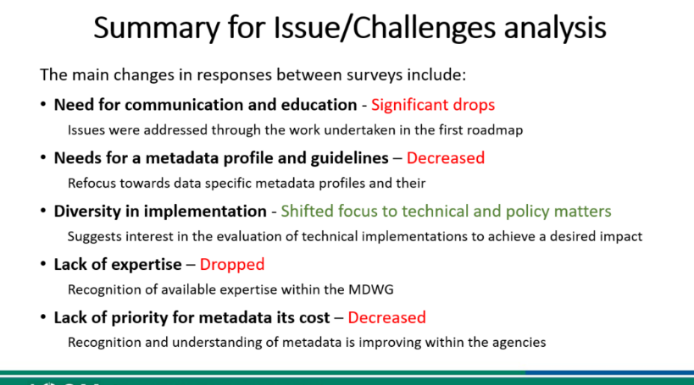
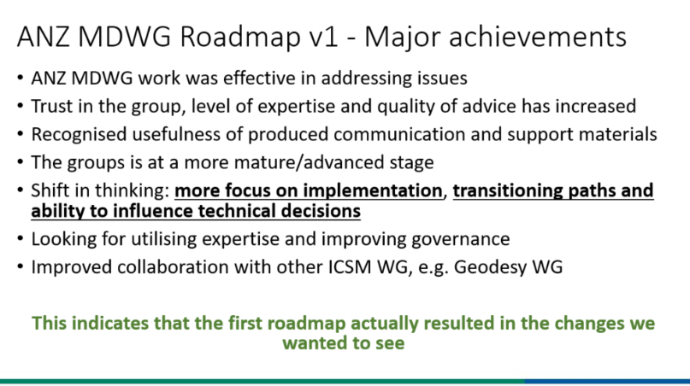
There is a strong need to influence technical implementation in agencies, there is a requirement for more specific educational and template resources. There was a strong request for expert support for data specific profiles and implementation examples.
There is also very strong desire for common shared tools for creation and validation for metadata profiles and creation of XML and improved technical governance.
Action 02/07/20: Workshop to be held in a few weeks to examine implementation examples and data specific examples.
Graham Logan noted the survey was a confirmation that the first MDWG roadmap had been an outstanding success, and that the group had delivered valuable outcomes. The second survey demonstrated that users wanted more detailed information and tools
A lot of data management needs to be automated and streamlined, developers are moving away from XML to GeoJSON. Simon Cox said there is some convergence between semantic and GeoJSON worlds.
There is a need to examine the options and revisit in Roadmap v2 (mapping to JSON have not yet been standardised), can DCAT be used as a bridge. LINZ have started using stack specification for recording metadata loosely based on OGC features API, feedback from the developers that they prefer this model, as ISO has too many fields to complete and is cumbersome to use. Jeremy would like to agree on a pathway forward for such work.
If there are significant changes required to standards, then there needs to be local resources provided to drive and enable ISO changes. Australia and New Zealand often have great ideas, but often there are no resources provided to have such changes implemented in the broader international community, there is also a lack of consistency of provision of such resources.
Action 03/07/20: Irina to raise with ICSM committee, resourcing for standards work.
Action 04/07/20: Review and possibly update crosswalks from Roadmap V1.
There is no clear indication of adoption of the standard, and there is still a large amount of work to be done with implementation. Clarity is required that within jurisdictions, some agencies have adopted the standard, others have not. There is no uniformity to adoption or implementation in jurisdictions.
Action 05/07/20: Irina to send out single question survey to MDWG members asking what ISO standard have agencies adopted.
Jeremy asked what is the overall state of maturity, do we have any idea of the uptake by developers of tools. There are some tools published on the MDWG web pages, but these are generic and a starting point only, more specific tools and collaboration such as with EDIWG is needed, and should be made a priority. Byron noted that there is use of Geonetwork and ISO19115-3 uptake across Europe and US, and tools are being driven by European stakeholders, INSPIRE and focus on GeoNetwork.

Editing Tools
ANZMet Lite will not be updated but need to test the need for other tools for current standard.
MDWG can produce templates with examples in XML - is this sufficient for jurisdictions?
There is support for templates, however tools will require further research and funding to produce. It would be preferable to have such tools in open source format. If organisations have open source tools, that will be easier for all to adopt and use.

Need to seek expert support for data specific implementations
Is this a priority for this group to address? The Elevation Group have already supplied input, and looking for feedback from other communities for their requirements.
There is a need to support drone imagery - will be big increase in data volumes soon, and associated metadata.
EMSINA was another use case that keen to support and assist metadata implementation. They wish to use a template to support collection of metadata on products and services.
Action 06/07/20: All members to consider what specific requirements they need to be supported, to send email to anz_mdwg@ga.gov.au
Use of common profiles will be aided by better technical governance, there is need for communication to industry, to ensure contracts deliver data against an agreed implementation of metadata standards. A template would allow consistent data collection by contractors. The Imagery group can assist with developing an initial template. Different requirements are needed for hyperspectral data compared to lidar, how far can a template stretch to cover these differences?
The FAIR principle gives a good overarching direction for governance and guidance, but without the technical details.
Irina would like to see a pilot done with imagery and elevation and work closely with EDIWG to develop a profile, technical governance with suppliers and what tools need to be developed.
Chris Body said that at recent meeting with OCG, they are doing work on drones and imagery to gather user requirements, and GA or MDWG should have some involvement.
Action 07/07/20: Chris Body to forward to Irina OGC details regarding drone requirements to engage with EDIWG.
Action 08/07/20: Irina and Shane Crossman to arrange joint EDIWG and MDWG workshop.

Simon, in the chat, said he could report on some work-in-progress in the Qld Department of Environment and Science, who are implementing a DCAT-based catalogue - initially internally, later externally. We have designed a DCAT profile 'QDCAT' with validation using SHACL. Part of the requirements-gathering involved inspecting old ISO/ANZLIC metadata records from QSpatial, and ensuring that there was a complete mapping to QDCAT.
The Go-FAIR office is developing tools for FIPs.
It will be a major topic at this upcoming symposium https://codata.org/call-for-sessions-posters-and-lightning-talks-international-fair-convergence-symposium-2020-deadline-20-july-2020/
ENVRI-FAIR is one of the testers.

EMSINA Requirements
Kane has previously presented to MDWG about EMSINA’s desire to be involved with MDWG. It is critically important during emergency responses for EMSINA to discover datasets quickly and efficiently.
EMSINA provided MDWG with another input of examples of issues and requirements. They want to implement metadata consistently, with a current target to have good set of metadata records developed by December 2020; and to have implemented consistent metadata by September 2021.
EMSINA has updated its website to provide users, clear information on metadata, user guides and standards. They have identified knowledge gaps and re-using ICSM materials, including the animation, as well as linking to the ICSM website. They gave very positive feedback that the work MDWG was undertaking was assisting with their work. They need XML template for datasets to help consistent metadata - can provide examples to be shown in template. EMSINA is looking for help with ISO 19115-3, best practice implementation, XML template.
Action 09/07/20: MDWG to add web page with links to different tools and work flows.
Chris Body said that OGC have also been doing work around emergency management, there may be some useful case studies that could be of assistance to Kane.
Irina has also been working with ANZLIC staff to have the links on that website updated.
Feedback from MDWG was that the EMSINA web page was a great communication piece, which others could duplicate, or link to. It would be useful for the MDWG pages to be updated/re-structured.

OGC and Standards – Chris Body
Much of standards work driven by needs from northern hemisphere. Australia needs to engage better to influence our requirements.
OGC is moving quickly on 19168-1 Geospatial APIs, now resolved and to be ratified as international standard in early August.
Imagery 19115-2:2019 extensions for acquisition and processing of imagery – review of comments in August.
Schemas for coverages for metadata is also being developed ISO19130-3
ISO19144 Landcover and Land use standard being revised with meta language by UN. Evert is co-chairing looking for further support from government agencies.
ISO19150-1 Geographic Info - Ontology framework being developed linked to OGC and W3C, Nic Car is helping to improve those relationships, to better understand ontologies and methodologies.
ISO19152 Land Administration Domain Model- supports UN sustainable development goals – Australia (GA), Canada and Netherlands active. Five parts to this work, including submissions of fundamentals of cadastre, 3D cadastre, in which ICSM has strong interest. [Need to talk to Norman Mueller GL Note]
Addressing – Margie Smith has had strong input, going through process of working draft.
Preservation of digital data and metadata for EO – to be published next month. Useful information for EDIWG as a framework to see if it meets our requirements.
Working Group 7 – significant contributions by Joel Haasdyk and Nick Brown in influencing dynamic coordinate reference systems.
Working Group 9 – Information management, referencing geospatial positioning by coordinates, another that Nick Brown has made significant contributions.
Data Quality – input by Ivana from FrontierSI and Curtin Uni. Also proposing to establish data quality register.
Discrete Global Grid – also a lot of input from Nick Brown’s group. Ballot closing in September.
BIM Addressing & GIS conceptual mapping – start stop project, trying to understand what geospatial and building communities want to achieve from this.
Intelligent Transportation Systems – draft technical report in ballot.
Action 10/07/20: If anyone wishes to contribute or participate in OGC or ISO work, please contact Chris Body.
Action 11/07/20: If anyone has a use case Chris Body could have, dealing with COVID19 and location based information, please send to him before September meeting. Particularly interested in emergency use cases (EMSINA).
OGC and SSSI hosting webinars over next few months, links on SSSI website. Final one 6th November is an Australia/New Zealand forum. Testbeds that are coming up, details are on OGC website.
UNGGIM supporting OGC work programs. ANZLIC have adopted the UNGGIM framework, the ANZLIC framework now mirrors UNGGIM.
Chat from Shanti: ISO19165-2 has been published this month.
Irina: ISO and OGC are working of standards and vocabularies supporting the temporary reference systems. Chris Little (OGC) was contacted about collaborative work. In response, Chris provided access to the ISO documents describing those standards. The Calendar Systems coldelist will be published through RVA to provide public access.
Day 2.
Irina recapped yesterday’s discussions, and set out today’s discussion on best practice guidelines.
Survey Agreement
Everyone agreed to accept results and assessment of the survey
Support for transformation pathways - based on slides presented yesterday – there was agreement from all, with further agreement on the priorities. Chris Body asked how will we address the priorities? Irina said we will look into fleshing out the roadmap based on agreement and endorsement by MDWG members of survey and priorities.

Metadata for Services – Byron Cochrane
Services an extension of previous work
Technical documentation has been developed over a year
Early work spurred by QGIS, Google Seasons of Doc and Open Source Geospatial Foundation
Wanting to improve documentation - problem for GeoNetwork and QGIS
Used model from django CMS software package - aim to get more consistent approach to documentation
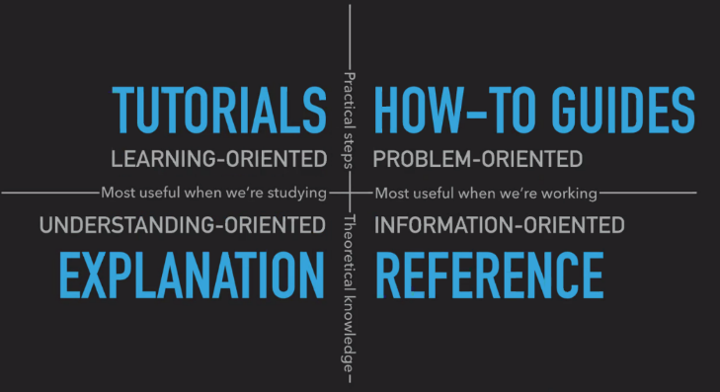
Need to break down technical documentation into four aspects - be clear about focus of each aspect:
- Tutorials - what matters, learning the software and how to use it, getting comfortable
- How to guides - cook book approach, templates with supporting documents pointing to references
- References - pointers to key documents and how things are done, more theoretical explanations
- Discussion documents - explaining background
Important to keep these four types of documents separate, to keep information and resources useful.
Cynefin framework, are we doing good practice or best practice ? Trying to move from good to best practice. Best practice takes element-centric approach.
ISO19115-1 Metadata Good Practice Guide - https://icsm-au.github.io/metadata-working-group/
Governance on best practice document has been put in place
Webpages created focus on elements that are required for a good metadata statement
Living document - current state of play with some things unresolved
Used same approach to documentation for best practice guide as for services best practice
Major issue - how to best capture link to service resource (does it point to a record or end point?)
Details need to be taken up in future working group meetings beginning next Friday.
Action 12/07/20: Look at details of Best Practice Guide at next week’s technical meeting. What do people want further from this document, what issues need to be addressed.
Agreement to review best practices for service document should be done in future working group meetings by a smaller focus group. Need to get to a point of identifying the minimum elements to allow services to meet FAIR principles, may need to cut down on elements presented by Byron. Should narrow scope to particular types of services, focus on which services are being described. This should be starting point for working group.
Chat: Kate Roberts - Could we be sent a WORD or PDF copy of the latest version of this Data Services draft? (is that easy to do Byron?)
From Byron Cochrane :Kate, do you think a “cookbook” type document be more useful to this end?
The W3C Spatial data on the Web is what is in large part what I modelled our best practice on https://www.w3.org/TR/sdw-bp/
A pdf version is available at https://github.com/icsm-au/metadata-working-group/blob/master/docs/services.pdf

Upgrades to the Australian Geospatial Reference System (AGRS)
There are three relevant datums, GDA2020; ATRF; AVWS. GDA2020 is a static datum, just like GDA94, features do not change with time but require to update data, due to movement of Australian plate.
Datasets can be compatible or compliant with GDA2020, depending on scale. Compliant is observed in GDA2020 or has been transformed to GDA2020. Compatible is low accuracy (3m or more) and there are insignificant changes between GDA94 and GDA2020.
Australian Vertical Working Surface (AVWS) is a new reference surface for heights in Ausgtralia without the bias and distortion present in the Australian Height Datum (AHD). AVWS heights can be computed from GNSS ellipsoidal heights through application of the Australian QuasiGeoid Model with accuracy of 4-8 cm.
Australian Terrestrial Reference Frame 2014 (ATRF) is dynamic and time dependant reflects ongoing plate motion, features will move over time. Coordinates need time stamp to allow movement of position. Needed for transport services, digital twins, location based services, and other services requiring precise positioning.
Key Elements for recording coordinate operations and modifications:
Reference System Identifier - need datum that data was captured in, what projection data was captured
Reference System Type – what system type the identifier belongs to: temporal, vertical, etc
Temporal extent, data observation time is needed for dynamic data, helps to identify epoch
Need to document authority for reference systems ideally with persistent identifier
May have a specific time or range of time for data capture
History of acquisition and transformation needs to be collected within lineage
Important to record source of data in lineage.
Document published on ICSM Metadata Working Group page https://www.icsm.gov.au/sites/default/files/Preparing%20metadata%20for%20the%20Australian%20Geospatial%20Reference%20System_v2.pdf
The document includes demonstrations of six examples of transformations to help users to understand how to apply metadata. If metadata is managed well, then some elements of metadata collection can be fully or semi-automated. Preselecting elements will allow pre-population of the metadata statement.
Comments:
Shanti :looks useful, will it be part of a geodetic specific handbook? or part of the metadata cookbook?
Chris Body asked what systems will be required to use 2020 in the future, what systems will be used? Who will be users – drones, intelligent transport, etc
Joel said, jurisdictions are providing data in GDA2020 from 30 June 2020; cadastral and legal information be provided in GDA2020 (NSW legal) and recommends all other data be in GDA2020, so there will be a ‘trickle down’ to all spatial datasets. ATRF will provide centimetre accuracy in real time so users can store collected data as GDA2020.
Chris asked what the costs were associated with such change. There have been costs, but it has not be calculated, however there are significant economic drivers to change to GDA2020 or ATRF.
Melanie asked about communication – there are fact sheets, technical specs, tools and webinars on the ICSM website under GDA2020 and AGRS topic headings. However it is difficult to reach every user. The GMIWG group can be approached if further information is required, through icsm@ga.gov.au or https://www.icsm.gov.au/datum/who-managing-gda-modernisation
Jenny asked what was end goal, to have every dataset transformed to GDA2020? Datasets are to be either compliant or compatible, depending on the accuracy of the particular dataset, there is no need for every dataset to be transformed or to be compliant. Will next ISO decision 19115 in December change this?
Have providers of GPS technology been involved in creating output files stating datum and epoch? GMIWG has had high level discussions with vendors, such as ESRI, however the datums are Australian specific, not international.
Irina asked the group if they thought the Best Practice document was ready to be published on the website. Most agreed it was too early to publish, and should be circulated as a draft for comment. The documentation for services was acknowledged to be very important.
Action 13/07/20: Irina to circulate the Best Practice document for comment.
Chat - Kate Roberts asked regarding AGRS . Should we consider identifying controlled terms ['GDA2020 compliant' etc] that could be used as keywords, with either 'place' or no keywordTypeCode ? Would make it easier from a discovery POV

Next meeting
The next meeting will be held in November, location to be decided closer to the date dependent on COVID restrictions. Possibly one day only.

Metadata for Global Archive – workshop 1
Tim Langlois presented his work on aggregating and annotating marine life data and publishing in in the Global Archive (globalarchive.org ). This use case contains several types of resources to document with various relationships between them ( https://marine-sampling-field-manual.github.io/) Includes:
- Imagery - this sort of template, then associate in this way.
- Annotations - apply this template and associate that way.
- Guidance that references this type of data.
- Datasets - some repeated from monitoring stations. Others from all different places - more exploratory - big spatial once off. Parks Australia is about designing longer term studies.
- Campaign - one to one hundred samples. Important to have metadata for each set (pair) so that imagery can be shared for other projects. Aggregation can be top level (campaign) and each image can be part of aggregate, all part of the same Campaign. Image metadata inherited from Campaign
The activity components:
- Annotation (collections of) - can related to one or more image (pair of individual)
- Summary - can relate to more than one annotation
- Synthesis - can relate to more than one summary or campaign
Tim: Currently capturing imagery data quite well so could already populate ISO template quite quickly possibly. It is a community standard that has evolved over time. Melanie, Nichol and I went through and have mapped many to the ISO fields.
Byron: Aggregated datasets are well supported in ISO 19115-3 - so can use this for multiple annotations and relationships between resource types. MDWG Best practice is focused at metadata attribute level - it provides guidance for use in different situations to provide metadata consistency across resource types. As such it is Generic but well suited for creating template metadata records and specific guidance that people can use per scenario.
Field Acquisition Information Management System (FAIMS) is designed to help researchers capture consistent metadata in the field. A new platform project recently funded by ARDC and is just starting up: it will be cross-platform (Android, iOS and Desktop) and self-serving allowing users to customise and deploy modules through a graphic user interface. This is the current community involved: come and join the party. We hope we can get the ANZLIC metadata/ICSM group to help include GDA 2020 and kinematic datums. A commercial equivalent would be ESRI Survey 123.
Sampling Design for ecological sampling
Requirement to respect sampling design in summary and synthesis to avoid errors. Field manuals explain that sampling design must be referenced within metadata so that it can be determined as relevant to the resultant data. To be explored in imagery workshops coming soon.
https://survey-design-field-manual.github.io/
If sampling design is a critical differentiator for discoverability and selection of data sets, it may be useful as a vocabulary written to keywords, with details as applicable under other elements?

Update on geodetic standards project with FrontierSI
Nick Brown’s presentation discussed challengers, and current activities, including deliverables, aiming to rectify issues with adoption of Positioning Australia recommendations. The presentation also described the GeodesyML as a new standard which helps to share, search and store geodetic data and metadata in a consistent way.
The group discussed how these activities and standards can help organisations across Australia to adopt the GDA2020 and AGRS; the potential collaboration between the ICSM MDWG and ICSM Geodesy WG.

Metadata for GDA2020 and AGRS – workshop 2
The workshop examined XML examples of implementation of the geographic, vertical and temporal reference systems, discussed challengers of improving understanding of importance of recording reference systems and history of data transformation between coordinate systems and epochs.
Jenny M: If the GPS CRS was set to GDA94 UTM Zone 54, a 2D coordinate system, should the captured coordinates and elevation be described as belonging to horizontal CRS EPSG:28354 and vertical CRS as EPSG:6499?
Nick Brown: GDA2020 ellipsoidal height to AHD is EPSG::8451
Shanti: At the moment Defence doesn't use the Ex_verticalExtent as the verticalCRS EPSG do not currently exist in the software applications nor does it systems have the ability to capture this information. The OGC Defence & Intelligence Working Group would be a good target for collaboration on adoption
Joel: New EGSG portal - for the updated EPSG v10.0+: https://beta.epsg.org/home.html
Meeting closed at 12:15

