Use Case – Under keel Clearance
AUSHYDROID

ICSM
CANBERRA, ACT

13 August 2019

Table of Contents
Issue 3
Introduction 3
Terms and Definitions 3
Use Case 3
Case Study 4

Issue
The majority of goods and raw materials that arrive and leave Australia do so by sea. The issue is how to optimize ship movement as well as the capacity of each vessel when they enter or leave a port.

Example: For a Capesize vessel, an extra 0.1m of draft equates to increasing cargo capacity by approximately 1200 tons. Per port, you may have up to 2000 vessels visit per year. That is a total loss of cargo load of 2.4 million tons. If the cost per ton of cargo was $100 per ton then the loss per vessel would be $120K and the loss per year would be $240mil.

Introduction

Under keel clearance is about maintaining the vertical distance between the ship’s hull and the ocean floor, keeping the keel free of the seabed and reduces the chances of running aground. This Use Case demonstrates how the creation of an AUSHYDROID improves vessel safety and movement through under-keel clearance management.

Terms and Definitions
AUSHYDROID the surface separation between the National Ellipsoid and chart datum.
GNSS Global Navigation Satellite System
National Ellipsoid Geocentric Datum of Australia 1994 (GDA94)
AHO Australian Hydrographic Office
NTU National Tidal Unit
Marine Pilot with navigational knowledge who manoeuvers vessels through dangerously shallow or congested waters. Also known as a harbor pilot.
Harbor Master has official responsibility for enforcing the regulations of a particular port, in order to ensure the safety of navigation, the security and operations of the port facilities.
Port Authority is a governmental or quasi-governmental authority that operates the ports.
SP9 ICSM Special Publications 9, The Australian Tides Manual
LAT Lowest astronomical tide
CPHS1 Certified Professional Hydrographic Surveyor Level 1
NM Nautical Mile
UKC Under Keel Clearance, minimum amount of water required under-keel of vessel

Use Case

Name of Use Case: | Under-keel Clearance
Created By: | ICSM AUSHYDROID WG | Last Updated By: | Z. Jayaswal
Date Created: | 20-May-2019 | Last Revision Date: | 13 Aug 2019

Description: | A vessel restricted by draft, entering or leaving a port where a limiting depth value exists in the shipping lane. The below describes how the limiting depth area can be managed dynamically to improve vessel movement.
Actors: | Vessel, Marine Pilot, Harbour Master, Port Authority, Australian Hydrographic Office (AHO)
Preconditions: | - Single value port datum, applied to whole port limits and channel area  - Minimum amount of water required under-keel of vessel (UKC)  - Limiting depth value in the port or channel  - Add values from 2 & 3 and plot that value as a line against the predicted tides for the location to provide sailing windows to allow vessel to transit in or out of port and along channels.
Postconditions: | - Sloping port and channel datum,  - Continuous tide monitoring at critical points  - Vessel management of under-keel clearance system  - Increased ship movement per sailing window and maximising the load per ship
Flow: | - Identify critical depth points in the port and along shipping channel  - Use Global Navigation Satellite System (GNSS) equipment at these points to establish a Tide Gauge Bench Mark relative to the National Ellipsoid and install permanent tide gauge(s). (3 days for GNSS and minimum of 35 days for tides observations,)  - Determine LAT from 2 (per LAT Tidal Epoch defined in SP9) and AUSHYDROID Relationship.  - Compare new and old sailing windows of opportunity  - Compare maximum draft available at critical limiting depth location.  - Provision of data and model to the AHO for use to update nautical chart and for National AUSHYDROID model.  - Implement a depth under-keel clearance system (if warranted)
Exceptions: | In step 2 of the Flow, if deployment of the instruments are not permanent, Flow stops at step 6.
Requirements: | The following requirements must be met before execution of the use case  - Funding availability must be verified prior to equipment and installation occurs  - Analysis of data (tidal height and GNSS)  - Establishing of chart datum in collaboration with AHO to plan update of nautical charts.  - AUSHYDROID observations to be submitted to AHO for inclusion in to a National AUSHYDROID model.

Case Study

Name of Use Case: | Under-keel Clearance – Port Hedland
Created By: | ICSM AUSHYDROID WG | Last Updated By: | Z.Jayaswal
Date Created: | 20-May-2019 | Last Revision Date: | 13-Aug-2019

Description: | Draft restricted vessels with an average loaded sailing draft of 18.2m, transiting the port and 22NM channel that feature draft limiting chart depths. The below describes how the limiting depths were managed by targeted maintenance dredging and conducting a tidal datum study and subsequent application of a sloping datum to improve draft restricted vessels drafts and sailing windows. The study was undertaken in 2012/2013.
Actors: | Dredging/Survey Manager, CPHS1 Hydrographic Surveyor, Harbour Master, Pilbara Port Authority, NTU, AHO
Preconditions: | - Single value port datum, applied to whole port limits and channel area  - Two (2) tide gauges, 1 in the port and 1 one-third along the 22NM long channel  - Minimum amount of UKC applied in the port’s dynamic under keel clearance system.  - Channel with a maintained depth through annual maintenance dredging.  - Port Authority application of siltation allowance for the port and channel in between maintenance dredging campaigns.  - Sailing window for loaded draft restricted vessels was at the time limited to six vessels at 30-minute intervals. See Figure 1
Postconditions: | - Five permanent (continuous) tide gauges were deployed along the length of the channel (22 NM long) and their relation to the National Ellipsoid established with the use of GNSS receivers.  - Advice on initial data collection standard was provided by the AHO. This information is now available in the ICSM SP9 Australian Tides Manual.  - National Tide Unit, Bureau of Meteorology provided the tidal analysis service to determine LAT at the five tide gauge locations on the initial 32 days of observations and subsequent annual data analysis and predictions.  - Maintenance dredging was targeted to remove ‘high spots’ in the channel.  - A dynamic under-keel clearance system was already in operation by the PPA and was updated with the post-dredge high-density bathymetry data, live tide gauge data and tide height predictions from all tide gauges, all relative to the newly established sloping datum. (went live in December 2013)  - Depths on Nautical charts for the port and channel were updated relative to the new port and sloping datum.  - Increase of up to two vessel per sailing window and increase load capacity of 0.7m per vessel See Figure 2

Sponsor Acceptance

Approved by the ICSM AUSHYDROID Working Group:

Date: 13 Aug 2019

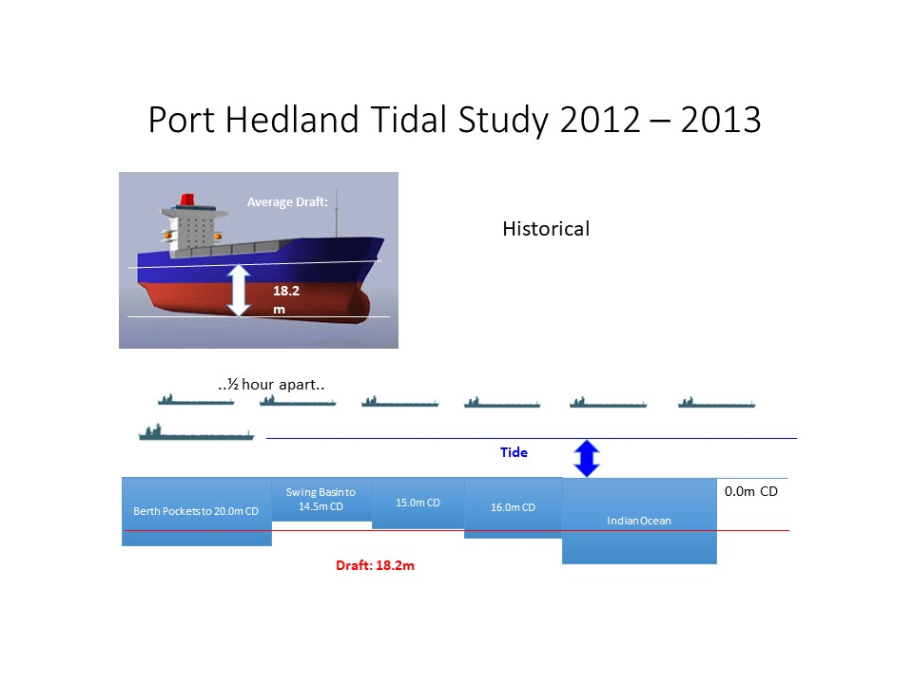
Figure 1: Port Hedland - Pre - AUSHYDROID
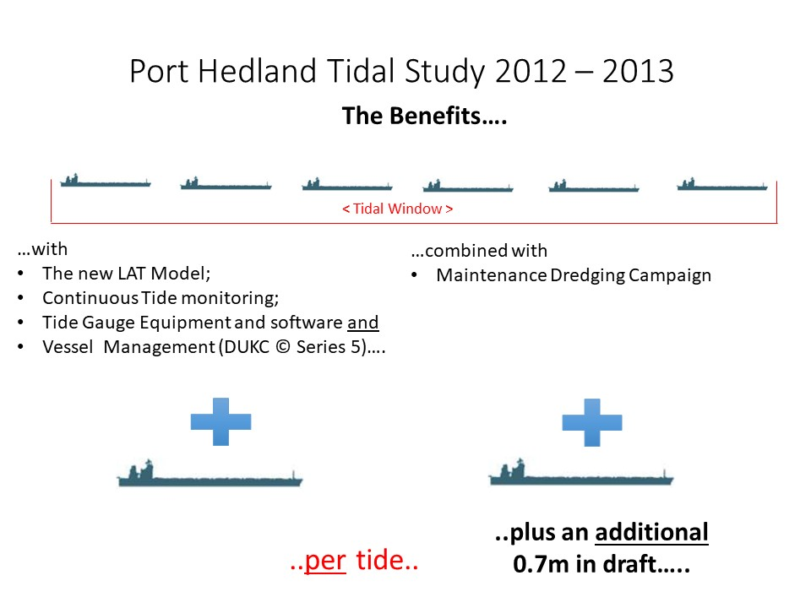
Figure 2: Port Hedland - Post AUSHYDROID

